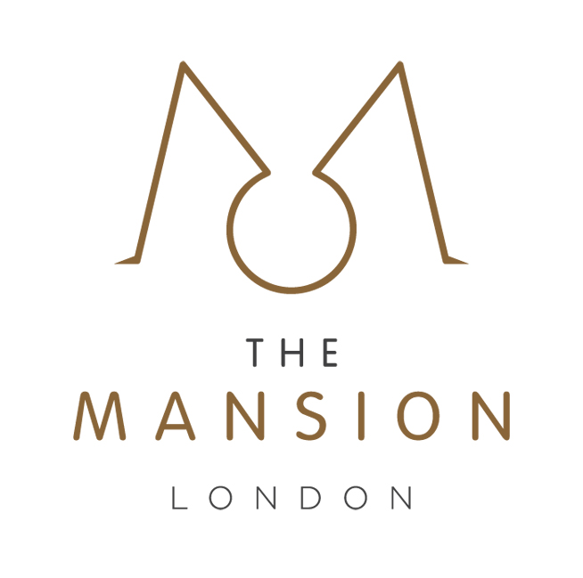

Set Menu
Midsummer Dream at the Blue Mansion
5 July 2025

Starter

Hamachi and tuna sashimi, seaweed salad, soy and wasabi dressing

Main

Wild bass, Spring greens, coconut, lime & peanut sauce

Dessert

Matcha & pomegranate cheesecake

